Christian Assembly Newsletter November 2019
Joy
- Contributed by Sis. Jeanette Chia

Joy
Joy is deep-seated. It springs from the heart. It is the fruit of the Holy Spirit. When we receive Jesus Christ as our Saviour and Lord, He gives us His Spirit who dwells in our hearts to help us to be more Christ-like. “He lives in you to help you and will be in you forever.” John 14:16.
Joy does not depend on outward circumstances. Happiness depends on outward happenings. When everyone in the family is well, you have a good job and passed your exam with good grades etc…then you are happy. But when sad events take place, sorrow fills your heart. You are devastated. Have you an inner joy when daily comforts fail? Experiencing deep inner joy is a gift from the Lord and it is everlasting. When we have the Lord, we have an inner source of comfort. Take it to the Lord in prayer, for the Lord has promised to be a helper of the helpless. In His arms He will take and shield you. His is ever-present. He surrounds you with His protection and care. God by His Spirit provides strength and power to overcome.
The Joy of Habakkuk
Habakkuk professed his deep faith in God despite outward sufferings to be endured. “Though the fig trees do not blossom nor fruit be on the vines, the produce of the olive fail and the fields yield no food, the flock be cut off from the fold and there be no herd in the stalls, yet I will rejoice in the Lord, I will joy in the God of my salvation. God is his strength and enables him to walk in high difficult places. Hab 3:17-19. God girded him with strength and made his way safe. Habakkuk’s vision of the coming king in chapter 3 cheered him. Christ coming was a comfort to Habakkuk and brought rejoicing for the deliverance of his people against the Chaldeans. Every believer’s hope is in Christ. He rewards those who trusts and seek Him. “The righteous shall live by his faith.” Hab 2:4. Let the joy of the Lord be our strength as in Nehemiah 8:10b.
The Prayers of Nehemiah
The Israelites were exile to Babylon for many years. The city Jerusalem was left in a very bad state- the walls were broken down and the gates burned. Nehemiah, the king’s cup-bearer was very sad when he saw the land. He prayed urgently to God for guidance. A city without walls is open to attack and invasion. Later he garnered the tools and equipment and workers to start rebuilding the walls. While starting the work, the workers were taunted and threatened by the enemy led by Sanballot, Tobiah and Gershem in Neh. 6. Led by Nehemiah, the Israelites continued working at the wall. The important point about Nehemiah was before he embarked on any decision, he would spend much time in prayer first seeking God’s will. We should follow his example- most of us would pray as a last resort when all else failed. We should pray first for God’s leading and guidance. “For God is at work in us both to will and do of His good pleasure.” Phil. 2:13.
And after much prayer they ignored the wiles of the enemy. “The people had a mind to work.” Neh. 4:6. God was with them. Thank God that He supplied the strength, power, wisdom and ability to His people. He will not fail nor forsake His people who trust in Him. Amidst the hard work, the joy and presence of the Lord was their strength. “Ask and you will receive that your joy may be full.” Jn. 16:24.
A Rejoicing Paul
When Paul and Silas was in prison in Philippi, they showed their joy amidst their suffering. They prayed and sang hymns to God at midnight. Suddenly there was a great earthquake and the prison doors were opened. The jailer in fear asked Paul: “What must I do to be saved?” Paul led him and his family to the Lord and at once they were baptised with great rejoicing. Acts 16:25-33 “There is joy in heaven before the angels of God over one sinner who repents.” Luke 15:10.
While imprisoned in Rome for his faith, Paul was assured that his suffering will result in promoting the good news of salvation. He rejoiced at the opportunity to preach Christ and to share the gospel ever to the prisoners and guards. Phil. 1:12-14. Living for Christ he was blessed with radiant joy- that he may finish the race in joy. For to him to live is Christ. We are also enjoined in Phil. 1:29 “ that we should not only believe in Christ but also to suffer for His sake.” He gives us overcoming power. Paul and the prisoners’ joy in Christ had the presence of Christ who is our sufficiency.
A prayer: As we read our Bible may our prayer be “that our love for the Lord may abound more and more with knowledge and discernment.” Phil. 1:9. Always look to Jesus who has given us life to the full in Jn. 10:10. Rejoice and give thanks to the Lord. The Bible tells us that “though He was rich, yet for our sakes He became poor that we by His poverty might be rich.” 2 Cor. 8:9. This is the grace of our Lord Jesus Christ.
Conclusion:
Abiding in the Lord and He in us and obeying His Word will enable us to bear fruit. He will then fill us with His joy and that our joy may be full.” John 15:7 & 11
Joy to the world the Lord has come,
Joy to the world the Lord will come!
Praise be to the Lord.

通知与消息

- 活动预告
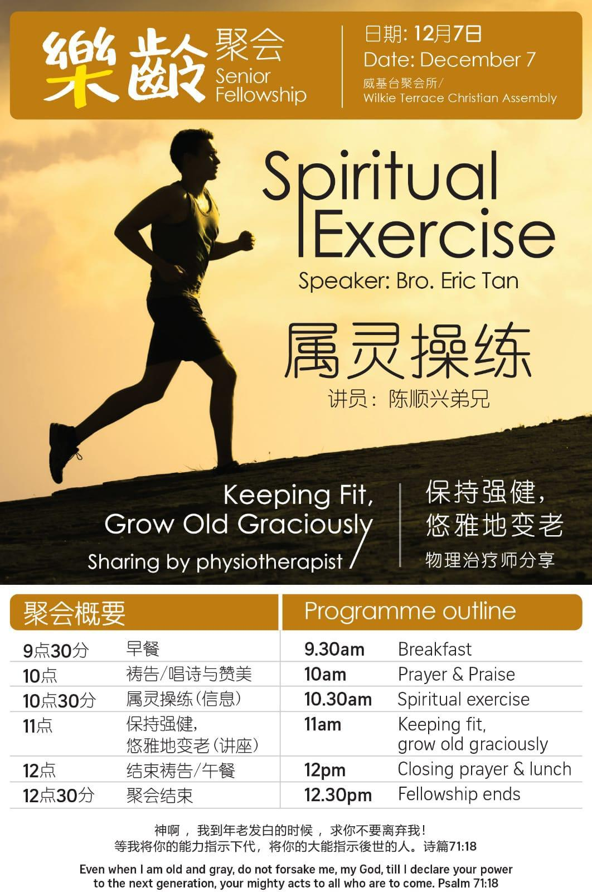
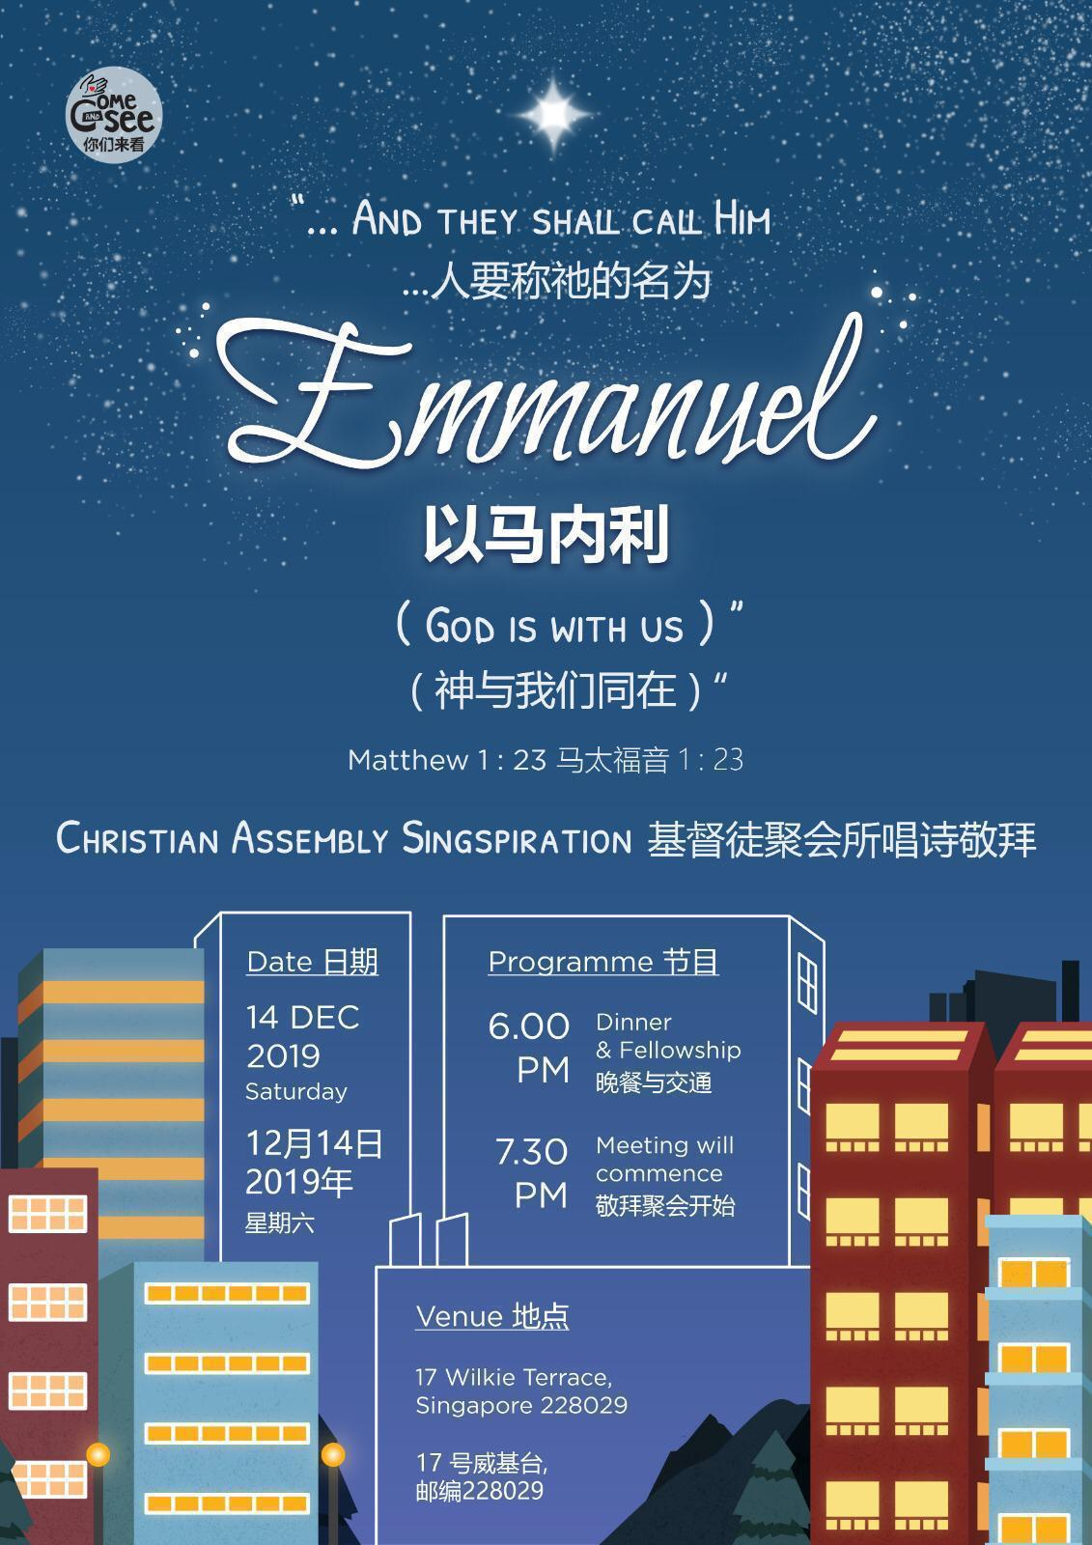
- 哀悼
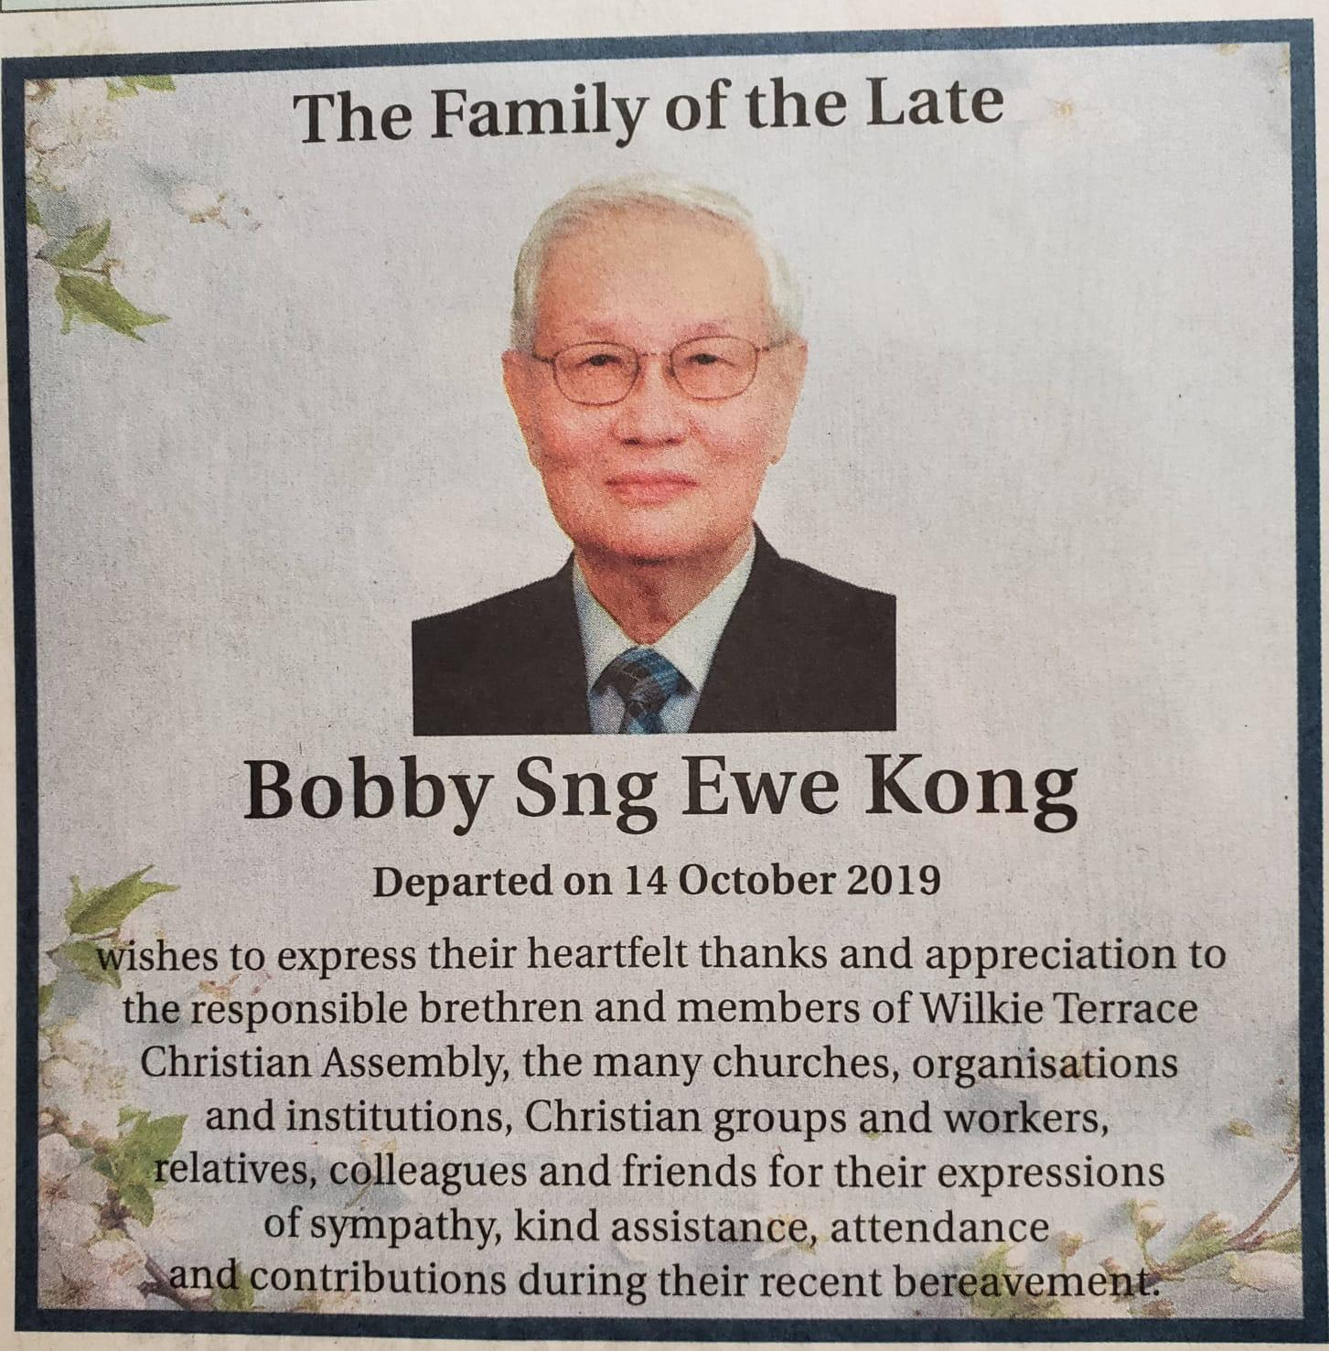
- 已故的孙耀光弟兄的家人向教会的负责弟兄和威基台聚会所的弟兄姊妹表达由衷的感谢，感谢他们在孙弟兄离世这段期间的关怀和安慰、帮助组织并出席弟兄的追思会，让一家人感受到了极大的安慰。

- 梁兆光弟兄于2019年11月2日被主接回天家，愿神安慰梁弟兄的家人。

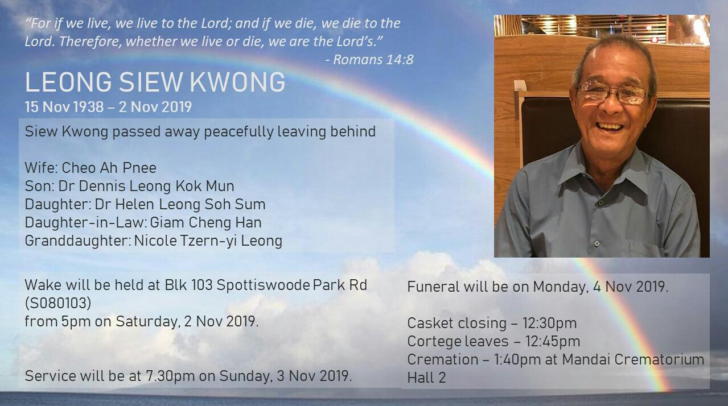

- Ong Teck Seng弟兄 (王宗卿姊妹的父亲) 弟兄于2019年11月18日被主接回天家，愿神安慰王弟兄的家人。
- 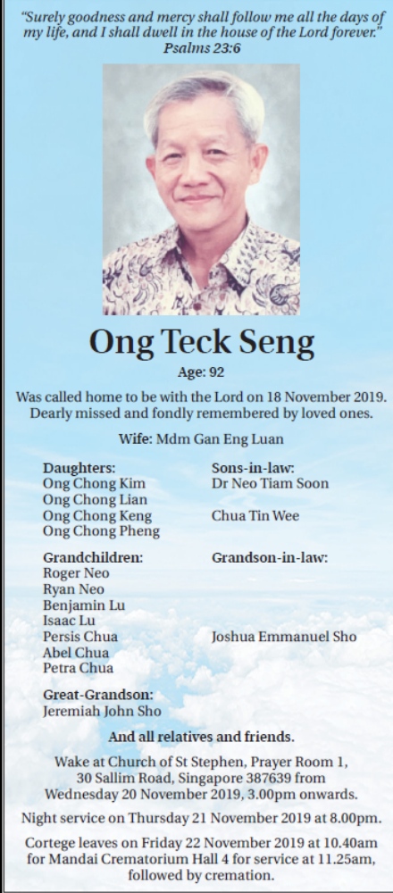


应当一无挂虑，只要凡事藉着祷告、祈求和感谢，将你们所要的告诉神。腓立比书 4：6
神所赐、出人意外的平安必在基督耶稣里保守你们的心怀意念。腓立比书 4：7

感恩
警醒祷告

为着神的信实和祝福向神献上感恩，感谢祂在过去的日子对乐龄聚会的把手和带领，也请继续为12月7日的乐龄聚会祷告：
- 求神能够按照年长弟兄姊妹的需要来赐下话语，借着讲员分享出来
- 帮助的弟兄姊妹能够在神的爱中彼此联络，同心合一的服事弟兄姊妹
- 愿年长的弟兄姊妹能够有温馨的聚集，也能够更多认识神

祷告事项
讲 台 侍 奉
为讲员祷告，愿神赐下祂的启示性的话语，使讲员能够讲出带着恩膏的话语以启示、鼓励并警戒教会

请为以下讲员祷告:
日期 | 威基台 | 泛亚
十二月一日 | 薄盛享 | 罗锡明
十二月八日 | Joseph Chu | Ling In Kee
十二月十五日 | Chris Lim (Morning)  Tan Boon Guan (Gospel Meeting) | Stephen Li
十二月廿二日 | Alan Wong | David Chong
十二月廿九日 | Tan Boon Guan | Freddy Boey

主 日 学

请为主日学老师祷告，愿他们有信心可以把神的话语教导给下一代人；也为父母祷告，求神帮助他们有信心将神的话带给孩子们，养育敬虔的后代。

长 老 和 执 事
请为长老和执事祷告 – 使他们可以在照管教会的事上在灵里合一，有爱心、有能力、有忠心做牧养的工。
初 级 部 教 会 营 – 2019年12月8号到12号
委员会成员可以在预备信息、计划、组织活动、后勤工作中仰望神
- 愿神膏抹讲员，预备好成为合神心意的器皿
- 帮助的弟兄姊妹带着喜乐和爱心服侍
- 求神预备每一个参加营会的人的心，使他们有敞开的心、赐给他们饥渴慕义的灵能够接受神的话语并顺服神的话
- 求神祝福每一个人都能够在基督里有更新的属灵经历，和神建立更加深厚的关系。
唱 诗 敬 拜
- 求神感动更多的人来参加这次的唱诗敬拜，也愿神赐下祂的同在触摸每一个人
- 求神帮助组织的弟兄姊妹能够在一切的事情中信靠神、仰望神
- 愿主在还未相信的人心中做奇妙的工作，使他们能够被基督得着
香 港 的 弟 兄 姊 妹
我们在祷告中纪念在过去几个月经历了暴力示威活动的香港的弟兄姊妹，愿神保守属祂的百姓

2020年 的 感 恩 聚 会 – 帖撒罗尼迦前书 5:18
在这一天，我们要向神献上感谢，感谢祂在2019年看顾保守我们，我们也仰望神，寻求祂在2020年对我们的引导。愿神帮助我们在2020年定睛在祂的身上，使我们的心思意念也常常转向祂。
请 在 祷 告 中 纪 念 那 些 身 体 不 适 的 以 及 不 能 来 参 加 聚 会 的 弟 兄 姊 妹

求神赐给他们力量、坚定的信心能够在这段痛苦的时光中持守信仰，也为那些照顾和支持他们的家人祷告：
- 黄伟伦弟兄
- 罗锡明弟兄
- 孙福兴弟兄
- 王惠溢姊妹
- Sis Ling Kam
- 张慈恩姊妹
- 李晓梅姊妹
- 刘以泉弟兄
- 李淑华姊妹
- 张修荣姊妹
- 其他神按名字纪念的弟兄姊妹。
教会事奉
教会的各项事奉需要你的祷告和参与，这将给基督的身体带来很大的鼓励。
全身都靠祂联络得合式，百节各按各职，照着各体的功用彼此相助，便叫身体渐渐增长，在爱中建立自己。
-以弗所书 4:16
请注意：
由于每个月的“信息”将准时在每个月的第一个主日出版，为了翻译和“信息”印刷的缘故，每个月的祷告事项将收集至每个月的第三个星期三。
每个月的第四个星期三所报告的祷告事项，除非下一期的《信息》出版时还有效，否则将不会被刊登。我们感谢教会弟兄姊妹的谅解。


教会信息 … 分享见证，照片和文章，勉励弟兄姊妹

载送需要 …请祷告有会驾车的弟兄姊妹能够志愿成为 福福音车司机，也求神感动有车的弟兄姊妹能够接送在不同地区的年长和年幼的弟兄姊妹。

